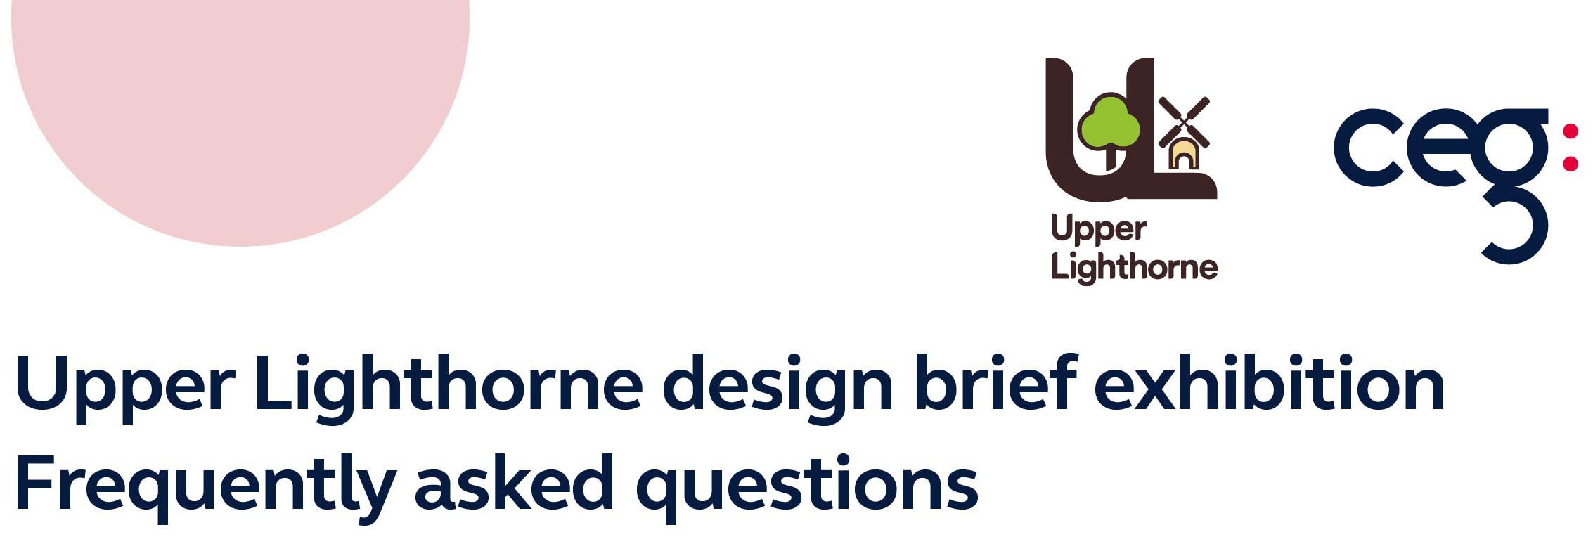

Q1) What are the timescales for delivery?
We are expecting the Spine Road to be delivered within the next 6-9 months, which will lead to the sale of the residential parcels within the Village Centre. The first phase of commercial uses (café, children’s nursery and food store) will likely commence delivery in 9-12 months.
Q2) When will the school come forwards, who is delivering it, what is the size and how will access/parking be managed?
Warwickshire County Council is delivering the school. The process to design the school has commenced and the school is required to be opened prior to occupation of 650th occupations on site.
Q3) What stage is the delivery of a doctor’s surgery at and can there be a temporary healthcare facility in the meantime?
The delivery of the surgery is currently with the ICB (Integrated Care Board). For a facility is to be delivered on site, the District Council needs to confirm that the land is required before the 725th occupations. There is nothing preventing this being delivered earlier, if the requirement has been established. We are working with various parties on the delivery of the facility.
Q4) How many homes have been delivered at the site to date?
As at the end of May 2023, 375 dwellings are occupied on site. Taylor Wimpey, Barratt and David Wilson Homes have delivered c250 homes to date and Bellway has delivered c130.
Q5) Can there be more greenery on Banbury Road?
The existing verge and vegetation will be retained along Banbury Road. It is proposed that the entrance to the Village Centre from the Banbury Road will have additional green space provided, following comments as part of the Design Review process.
Q6) Why is a hotel proposed, does this need to be included?
Only if there is operator interest.
Q7) Can there be some unique village buildings?
The Design Review will provide parameters for the design of buildings in the Village Centre. Due to the nature of the Village Centre, the design here will be different to that of the rest of the site.
Q8) Will there be a segregated cycle way?
Yes, across parts of the site
Q9) Will any trees be removed on the bridlepath?
In the Design Brief no trees are identified for removal from the bridleway

Q10) Can a defibrillator be installed within the village centre?
Yes, one must be delivered alongside the delivery of the first commercial use in the Village Centre
Q11) Will there be any high-rise buildings?
There will be some feature buildings within the village centre. Within the Village Centre they would be up to a maximum of four storeys
Q12) Will you design out anti-social behaviour?
The developer would use Secured by Design guidance.
Q13) Can there be any art, sculpture or a WWII memorial?
It is intended for the provision of public art as part of the Village Centre, this is included within the brief and will be considered in detail in the reserved matters applications.
Q14) Who will maintain the green spaces, and will these include seating, biodiversity initiatives and areas providing shade?
Trust Green will maintain the green spaces. As landscaping matures, shade will be provided.
Q15) How will the rectangular design of the residential allocate parking to houses, provide vehicle charging points and provide public and private garden space?
All Reserved Matters applications have to provide garden space to houses. Vehicle charging points will also be provided.
Q16) Will the Design Guide give guidance on the proportion of private, affordable and social housing in the village centre. Will the proportions be in line with the average proportions for the whole development?
The reserved matter application for the residential parcels within the VC will prescribe the mix and tenure of housing here. The Village Centre will provide up to 40% of the dwellings as affordable homes.
Q17) Will there be allotments in the Village Centre?
The framework plan in the Design Brief document does include space for allotments / orchards.
Q18) What is the trigger for improvements to bus services?
Payments to the “Standard Bus Service” as defined in the S106 agreement are phased throughout the scheme. A total of £1.6m (index linked) will be paid to improve the existing bus service in the area on a phased basis (approximately £500k has been paid to-date). The regularity of the bus service is to increase as the development progressed in accordance with the table below:
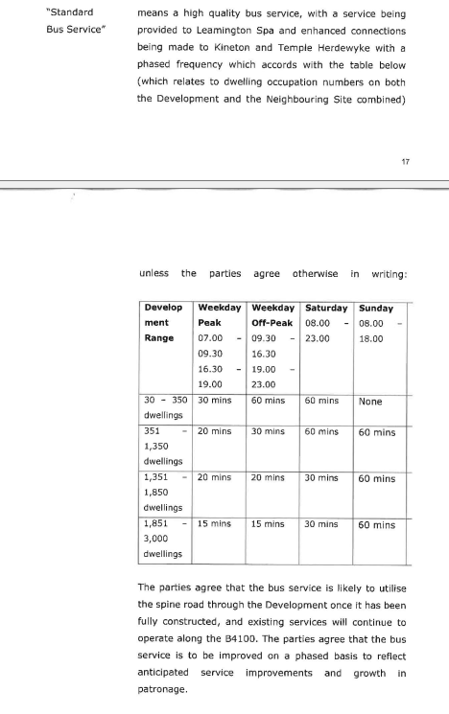

Q19) Will a mix of uses be delivered within the village centre? There were requests for specific uses within the village centre, such as the following:
- A pet shop
- A recycling centre
- A café where people who work from home could use to hot desk and have company
- A pub and or restaurant
- More green spaces
- A youth club/facility for youths
- Library
- A range of shops
- Post office
- Dentist
- Hairdresser
- Takeaways
- Grocers
- Small business space
- A pharmacy
- Places for evening activities
- A gym
- Independent shops
- A village hall
- A care home
- EV charging points for the public
The Village Centre will be delivered by Hintons. Currently interest has been secured by Sainsburys and Little Pioneers and a café franchise and the Hintons team continues to liaise with other operators. They will prepare a Reserved Matters (detailed) planning application, inline with the Design Guide once it is approved by the Local Planning Authority. Further information about the wider mix of uses will be available as this planning application processes. Subject to approval they aim to be on site in 2024 delivering the Village Centre.
Q20) Where can I review the Design Brief and how do I ask questions?
It is available on the website www.upperlighthorne.co.uk
You can contact the team by emailing Victoria.walker@ceg.co.uk

